Data Binding, Lifecycle Hooks & Component Communication

Task-1
Update src/app/pages/home/home.ts
import { Component, OnInit, OnDestroy } from '@angular/core';
import { CommonModule } from '@angular/common';
import { FormsModule } from '@angular/forms';

@Component({
selector: 'app-home',
standalone: true,
imports: [CommonModule, FormsModule],
templateUrl: './home.html',
styleUrl: './home.css'
})
export class HomeComponent implements OnInit, OnDestroy {
portalName: string = 'Student Course Portal';
isPortalActive: boolean = true;
message: string = '';
searchTerm: string = '';
onEnrollClick(): void {
this.message = 'Enrollment opened!';
}
ngOnInit(): void {
console.log('HomeComponent initialised — courses loaded');
}
ngOnDestroy(): void {
console.log('HomeComponent destroyed');
}
}
Update src/app/pages/home/home.html:
<section class="welcome-section">
<h1>Welcome to the {{ portalName }}</h1>
<p>Manage your enrolled courses, view your academic progress, and update your profile all in one place.</p>

<div class="search-box">
<input type="text" [(ngModel)]="searchTerm" placeholder="Search courses..." />
<p>Searching for: {{ searchTerm }}</p>
</div>
<div class="action-box">
<button [disabled]="!isPortalActive" (click)="onEnrollClick()">
Enroll Now
</button>
<p *ngIf="message" class="message">{{ message }}</p>
</div>

<div class="stats-row">
<div class="stat-card">
<h3>Courses Available</h3>
<p>12</p>
</div>
<div class="stat-card">
<h3>Enrolled</h3>
<p>3</p>
</div>
<div class="stat-card">
<h3>GPA</h3>
<p>3.8</p>
</div>
</div>
</section>
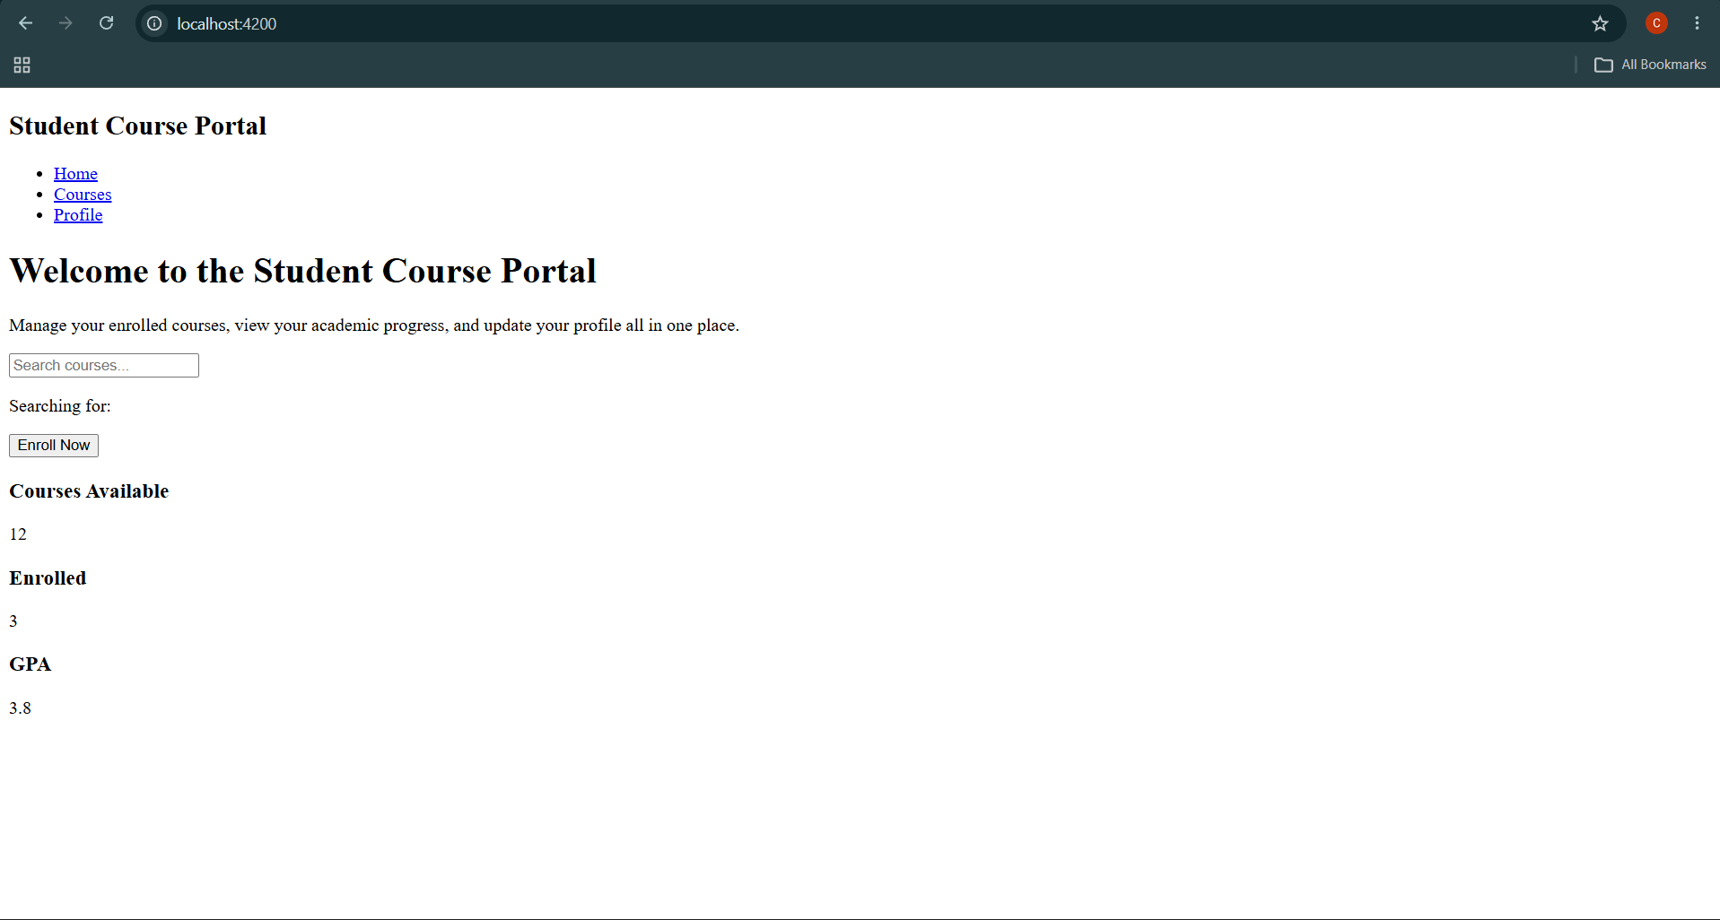
Task-2&Task-3:
Execute
ng generate component components/course-card
Update src/app/components/course-card/course-card.ts
import { Component, Input, Output, EventEmitter, OnChanges, SimpleChanges } from '@angular/core';
import { CommonModule } from '@angular/common';

export interface Course {
id: number;
name: string;
code: string;
credits: number;
}

@Component({
selector: 'app-course-card',
standalone: true,
imports: [CommonModule],
templateUrl: './course-card.html',
styleUrl: './course-card.css'
})
export class CourseCardComponent implements OnChanges {
@Input() course!: Course;

@Output() enrollRequested = new EventEmitter<number>();

ngOnChanges(changes: SimpleChanges): void {
if (changes['course']) {
console.log('Course input changed:', {
previousValue: changes['course'].previousValue,
currentValue: changes['course'].currentValue,
firstChange: changes['course'].isFirstChange()
});
}
}

onEnroll(): void {
this.enrollRequested.emit(this.course.id);
}
}

Update src/app/components/course-card/course-card.html
<div class="course-card" *ngIf="course">
<h3>{{ course.name }}</h3>
<p><strong>Code:</strong> {{ course.code }}</p>
<p><strong>Credits:</strong> {{ course.credits }}</p>
<button (click)="onEnroll()">Enroll</button>
</div>
Update src/app/pages/course-list/course-list.ts
import { Component } from '@angular/core';
import { CommonModule } from '@angular/common';
import { CourseCardComponent, Course } from '../../components/course-card/course-card';

@Component({
selector: 'app-course-list',
standalone: true,
imports: [CommonModule, CourseCardComponent],
templateUrl: './course-list.html',
styleUrl: './course-list.css'
})
export class CourseListComponent {

selectedCourseId: number | null = null;

courses: Course[] = [
{ id: 101, name: 'Angular Fundamentals', code: 'CS-201', credits: 4 },
{ id: 102, name: 'TypeScript & ES6 Basics', code: 'CS-202', credits: 3 },
{ id: 103, name: 'RxJS & Reactive Programming', code: 'CS-301', credits: 4 },
{ id: 104, name: 'Web Architecture & REST APIs', code: 'CS-302', credits: 3 },
{ id: 105, name: 'UI/UX Design Systems', code: 'DES-101', credits: 2 }
];

onEnroll(courseId: number): void {
console.log('Enrolling in course: ' + courseId);
this.selectedCourseId = courseId;
}
}

Update src/app/pages/course-list/course-list.html
<section class="course-list-container">
<h2>Available Courses</h2>

<div class="selection-status" *ngIf="selectedCourseId">
<p>Selected course ID: <strong>{{ selectedCourseId }}</strong></p>
</div>

<div class="card-grid">
<app-course-card
*ngFor="let c of courses"
[course]="c"
(enrollRequested)="onEnroll($event)">
</app-course-card>
</div>
</section>

